**Covid – 19**

Table of contents

Contents

Table of Figures 3

Executive Summary 4

1. Introduction 5

2. Methodology 5

3. Results and Findings 6

3.1 Continent wise trend: 7

3.2 Country Wise Trend: 8

3.3 Time Series models: 8

3.3.1 Autoforecasting Using ARIMAX and ESM models: 8

3.3.2 Naïve Model: 9

3.4 Model Comparison 11

3.5 Findings: 12

3.5.1 Continent Wise Forecast 12

4. Discussion 15

5. Conclusion 16

6. Recommendations 16

# Table of Figures

Figure 1: Worldwide Deaths per day 6

Figure 2: North and South America deaths per day 7

Figure 3: Asia Deaths per Day 7

Figure 4: Africa deaths per day 7

Figure 5: Europe deaths per day 7

Figure 6: India deaths per day 8

Figure 7: USA deaths per day 8

Figure 8: MAPE distribution and Model Family for autoforecasting 8

Figure 9: Type of model used for autoforecasting 9

Figure 10: Forecasted Trend (autoforecasting) 9

Figure 11: Naive Model Results 10

Figure 12: Hierarchical Model results, country 10

Figure 13:Hierarchical modelling results, continent 10

Figure 14: Forecasted trend for Hierarchical model 11

Figure 15: Model Comparison 11

Figure 16: Forecasted trend for Africa 12

Figure 17: Forecasted trend for Europe 13

Figure 18: Forecasted trend for North & South America 13

Figure 19: Forecasted trend for Asia 14

Figure 20: Effect of 10% increase in the forecasted values 14

Figure 21: Effect of 10% decrease in the forecasted values 15

# Executive Summary

The study below provides a detailed investigation into the situation of deaths recorded each day due to Covid 19 worldwide. The aim of the study is to provide useful insights to be used by policy makers and world leaders to make effective decisions about controlling the spread and rise in the number of deaths per day. First, exploratory time series analysis is used to get a grip on the present trend for each country and continent. Then, three distinct time series models are used to forecast trends, namely Autoforecasting using ARIMA and ESM, naïve modelling using 4 day moving average and Hierarchical modelling.

These three models are then compared based on their performance, and Hierarchical modelling is taken to be the best model, as it has the least mean absolute percentage error and weighted mean absolute percentage error. Once the model is chosen, this model is used to forecast trends for major continents and countries, as well as to assess the worldwide trend for the foreseeable future. The following results are obtained from the same:

* Africa and Asia are expected to have an increase in the number of deaths recorded per day
* North and South America have extremely high numbers of deaths recorded per day, and will continue to have for the foreseeable future
* Europe appears to be doing well, and has been on a downward trend since May
* USA, India, Russia, Brazil are still showing incredibly high numbers of deaths per day, and still remain to be on an upward trend
* Worldwide trend appears to have an element of seasonality, and the forecasted values can be seen as follows:

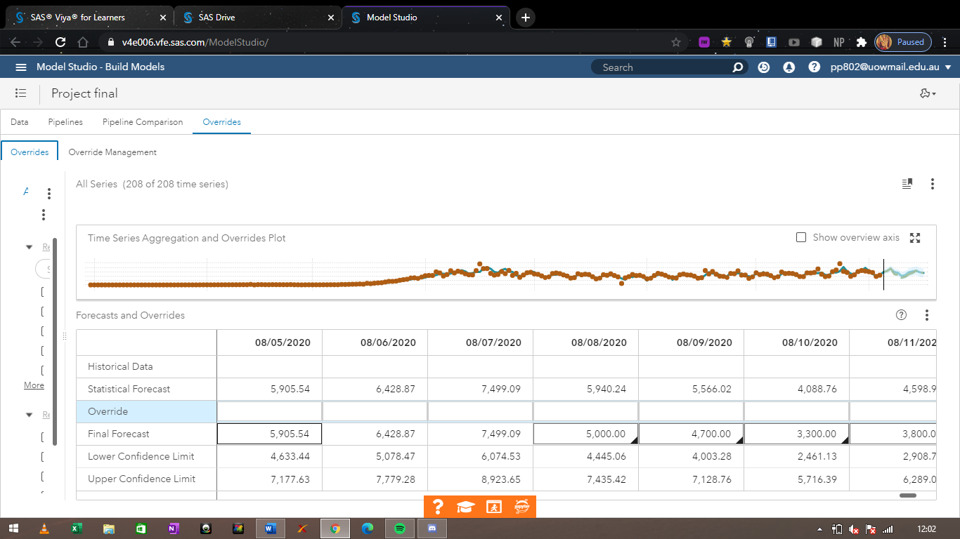

# Introduction

From epidemic, to pandemic, Covid – 19 has taken this world like a storm. Our unpreparedness for a crisis of this magnitude has resulted in unfathomable damages and hundreds of thousands of deaths. So far, the virus has managed to kill approximately 700,000 people worldwide, and seems to show no sign of stopping or slowing down. If this continues at the same rate, then the total number of deaths can potentially reach in millions across continents and even countries. Thus, the need to take effective and efficient decisions to control the situation is important, now more than ever.

This study provides a trend analysis of the number of deaths across different countries and continents, with the purpose of obtaining useful insights into the future of the same. Forecasting and predicting number of deaths recorded per day for each country and continent will help in making decision regarding allocation of resources and controlling the spread.

# Methodology

The study focuses on identifying future trends, taking deaths recorded per day as the dependent variable. Data used in the analysis is from 1st of January, 2020 till 1st of August, 2020, and shows information on various heads like confirmed cases, deaths, etc for each country and continent. Exploratory time series analysis is first conducted to understand the nature and type of data, as well as the trend that has existed in the past, for important countries and continents.

Then, 3 distinct models are used to forecast or predict the number of deaths recorded per day. These models are; autoforecasting using ARIMA and ESM, Naïve modelling using 4 day moving average, and Hierarchical modelling using top down reconciliation method. Top down reconciliation method is used as it provides the best results out of all other options. Finally, the effect of a 10% increase and decrease in predicted values is assessed on the future trend of number of deaths recorded per day. SAS Viya is used for the analysis.

# 3. Results and Findings

The first and foremost part of this study is exploratory analysis. Data is present under different heads/variables such as deaths per day and confirmed cases per day, for each country and continent. The graph below shows the distribution of the total number of deaths recorded for everyday worldwide since the 1st of January, 2020.

Figure 1: Worldwide Deaths per day

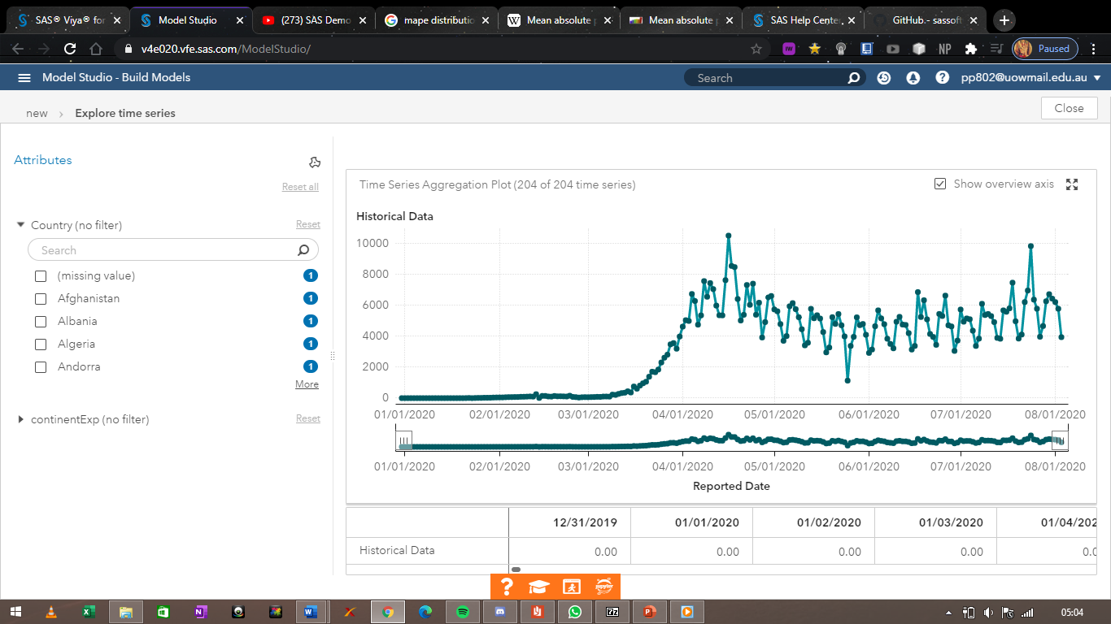

It is evident that the number of deaths recorded per day started to rise drastically mid-march, and reached a peak level of above 10,000 deaths per day in mid-April. As lockdown was imposed in numerous countries, the number of deaths recorded per day slowly and gradually started to decline, but started to rise again after the first week of June wherein many leaders lifted the lockdown in their respective countries. It is essential to look at the trend of every continent and some major countries, which can be shown as follows:

## 3.1 Continent wise trend:

Figure 2: North and South America deaths per day

Figure 3: Asia Deaths per Day

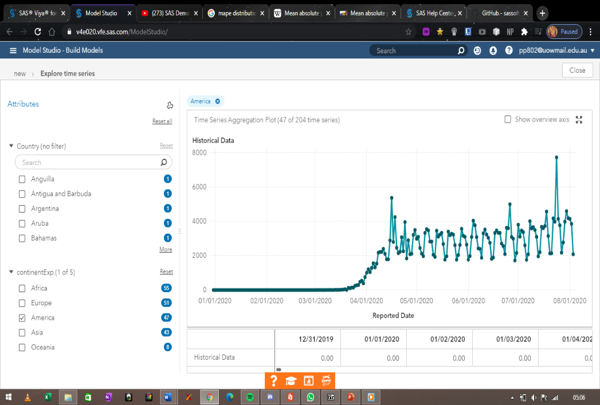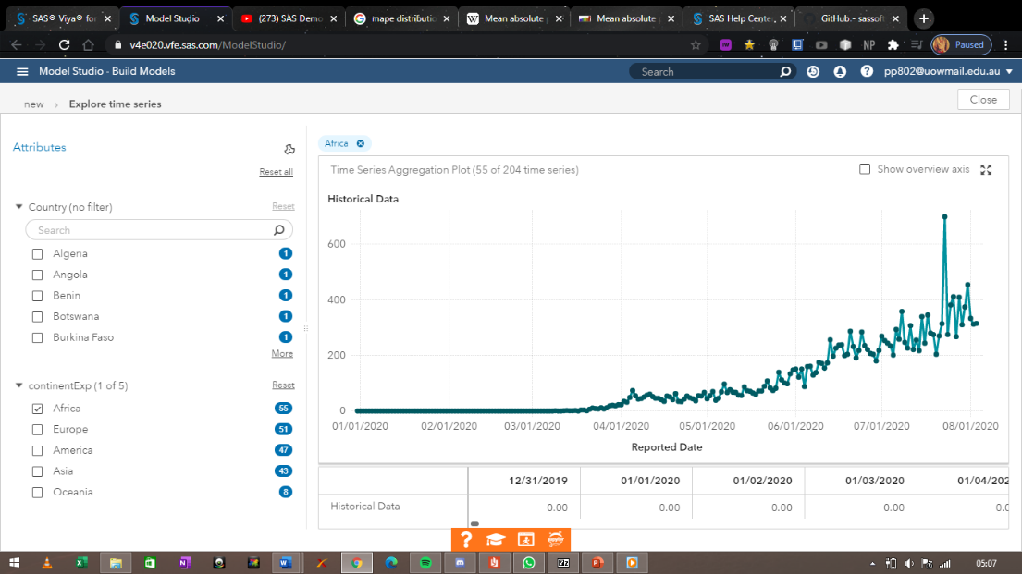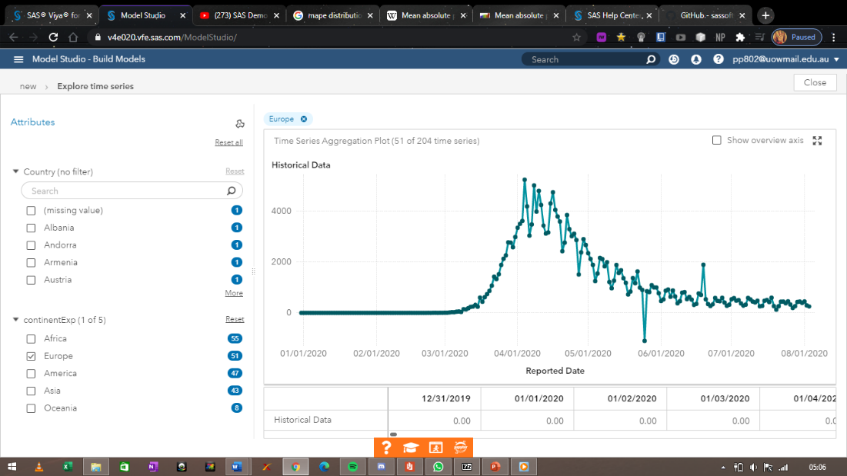

Figure 4: Africa deaths per day

Figure 5: Europe deaths per day

From the above graphs, it is evident that the number of deaths recorded per day for Asia has so far been on an upward trend, with more and more deaths being recorded everyday. However, the last 2 weeks show that the trend is starting to de accelerate or slow down. The number of deaths being recorded in North and South America are more than that of most of the other continents combines. The trend, though upward, does not give a clear picture. As far as Europe is concerned, the continent reached a peak point in April, but has since been on a downward trend attributing to the quick reaction in the continent. Like Asia, Africa too seems to be on an upward trend, but has the least number of deaths recorded per day among all continents.

It is also important to look at the trend of some important countries, which can be seen as follows:

## 3.2 Country Wise Trend:

Figure 6: India deaths per day

Figure 7: USA deaths per day

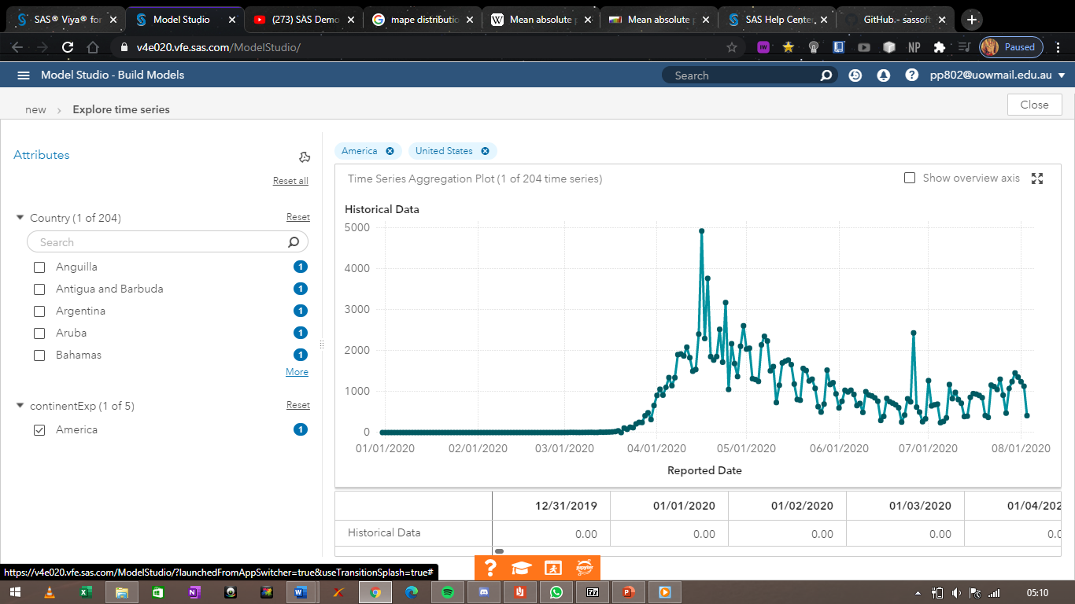

While India appears to be on an uptrend, USA is gradually facing a de accelerated trend. Similarly, USA appears to have already attained the peak in the trend, whereas India hasn’t so far.

Now that exploring the data is finished, the study shifts towards forecasting and analysing the data.

## 3.3 Time Series models:

Deaths per day is taken as the dependent variable, confirmed cases as independent or exogeneous variable, and finally country as well as continent variables are taken as BY or categorical variables. In this study, the researcher has undertaken three different models to forecast and find useful insights, which are; ARIMA model, ESM model, Hierarchical forecasting and Naïve modelling. The results of these models can be seen as follows:

### 3.3.1 Autoforecasting Using ARIMAX and ESM models:

Using SAS Viya, the first type of analysis method employed is that of autoforecasting, which automatically selects the best possible model for data provided. After running the pipeline, we get the following results:

Figure 8: MAPE distribution and Model Family for autoforecasting

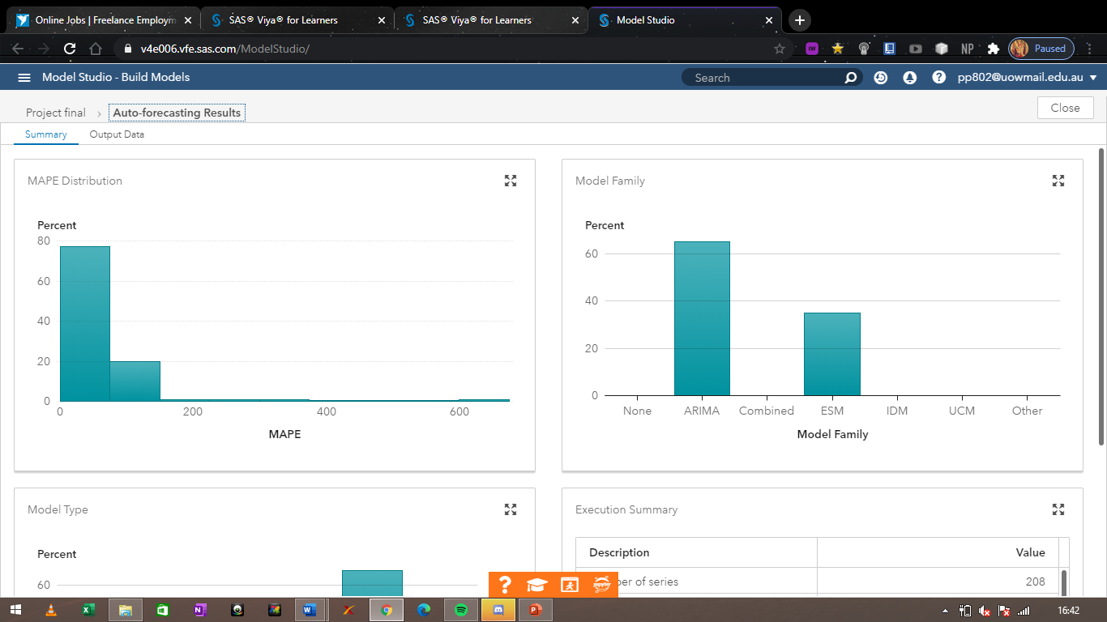

The graphs above show the mean absolute percentage error distribution as well as the type of model most used. It is evident that most of the forecasting model (80%) lies in the lower levels of the MAPE distribution. ARIMA model was the most widely used model, with about 65%.

Figure 9: Type of model used for autoforecasting

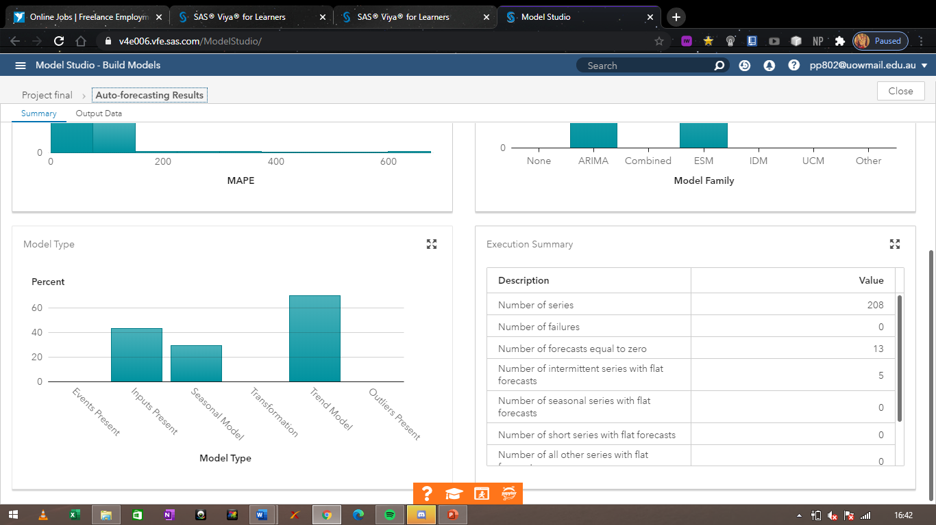

The above graph shows that about 65% of the data was modelled using a Trend model, while only 25% of it had some seasonal element in it. The following graph shows the forecasted trend of number of deaths recorded worldwide produced by the model:

Figure 10: Forecasted Trend (autoforecasting)

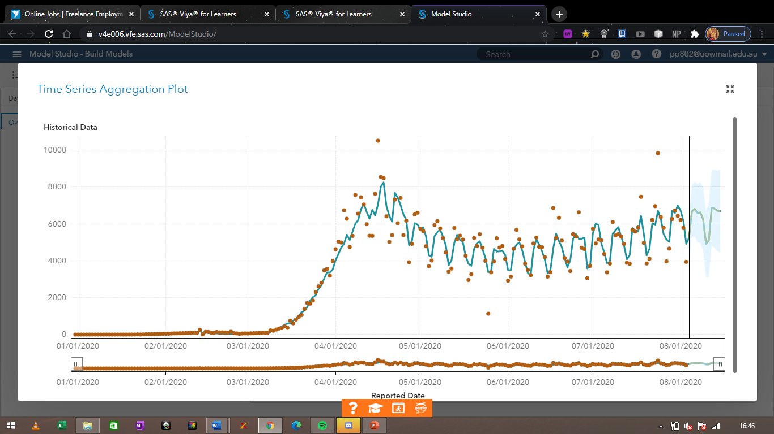

### 3.3.2 Naïve Model:

A simple moving average analysis is used to find similar predictions and forecasts. The results can be obtained as follows:

Figure 11: Naive Model Results

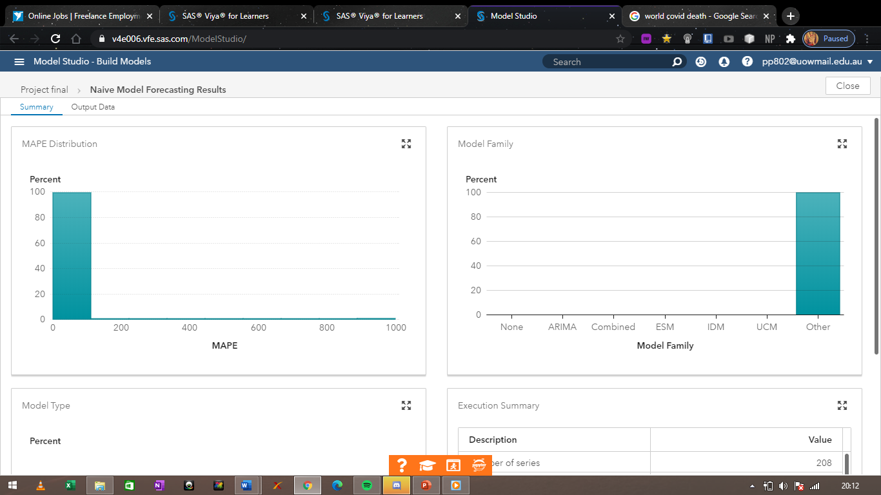

100% of the data falls in the lower range of the MAPE distribution. None of the models mentioned are used since the data is forecasted solely based on a 4 day moving average analysis.

3.3.3 Hierarchical Model:

Finally, Hierarchical modelling is employed to make the similar predictions and forecasts on the worldwide deaths per day. Top down reconciliation method is used as it provided the best results out of all 3 reconciliation methods. The results can be shown as follows:

Figure 12: Hierarchical Model results, country

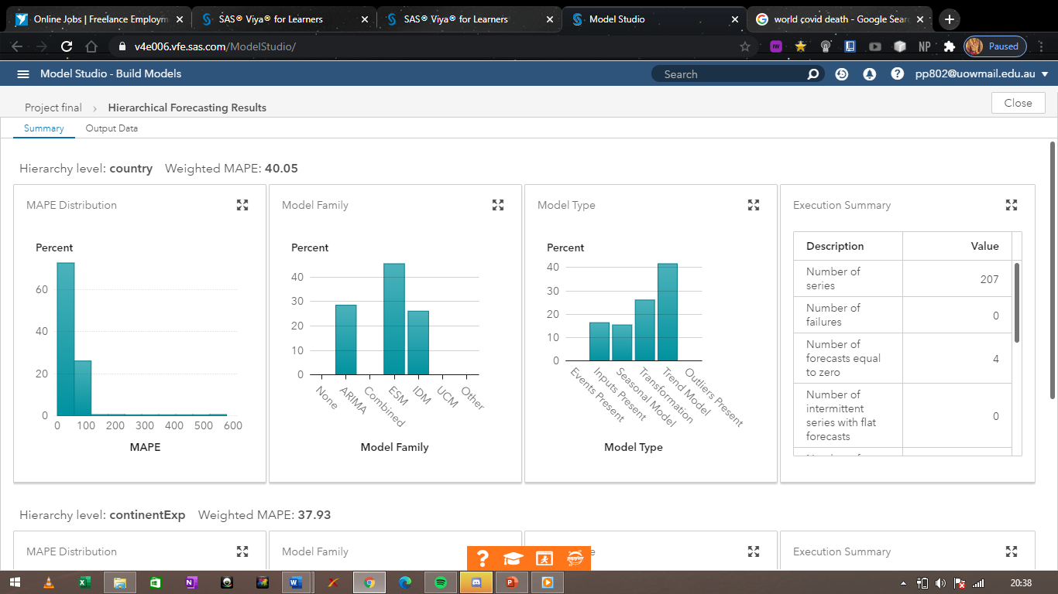

Figure 13:Hierarchical modelling results, continent

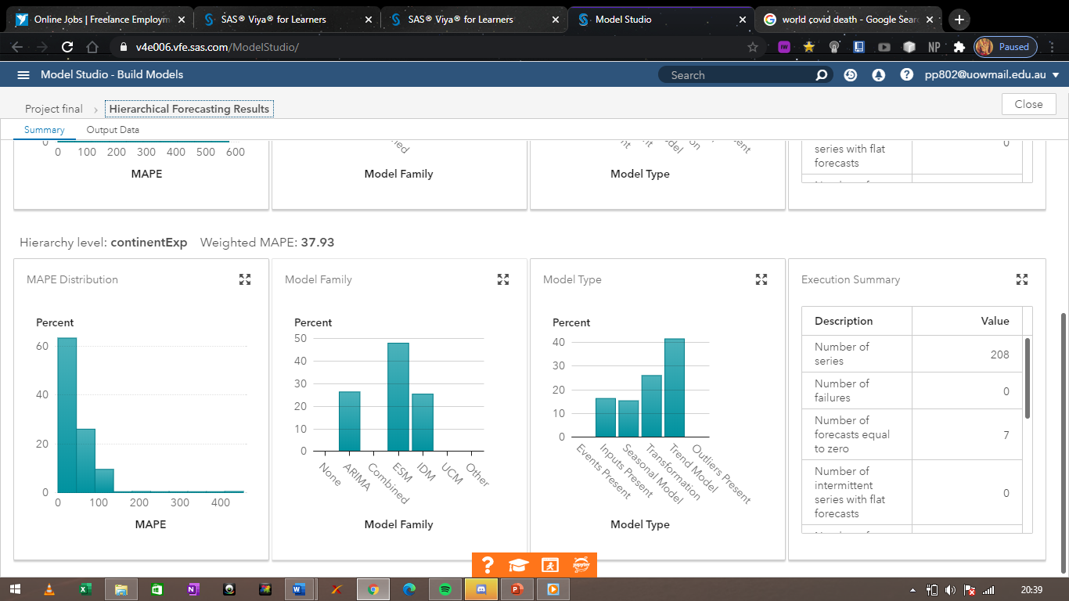

It is evident from the above graphs that continent provided a much lesser weighted average percentage error than country. Thus, top down approach for reconciliation proved to be the most efficient. Both country and continent had similar results, wherein trend models were most in use.

Figure 14: Forecasted trend for Hierarchical model

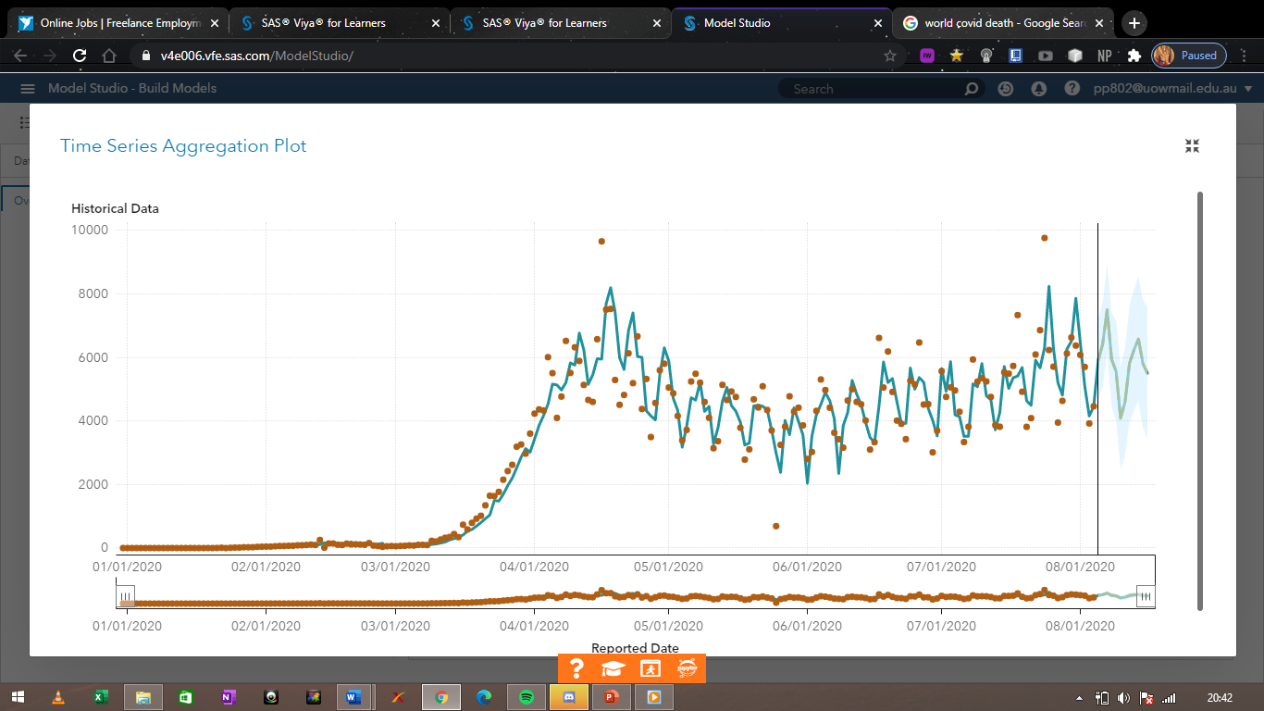

The above figure shows the forecasted trend of number of deaths per day worldwide, using Hierarchical modelling.

## 3.4 Model Comparison

The final part of the analysis focuses on the comparison between the three models, and can be shown as follows:

Figure 15: Model Comparison

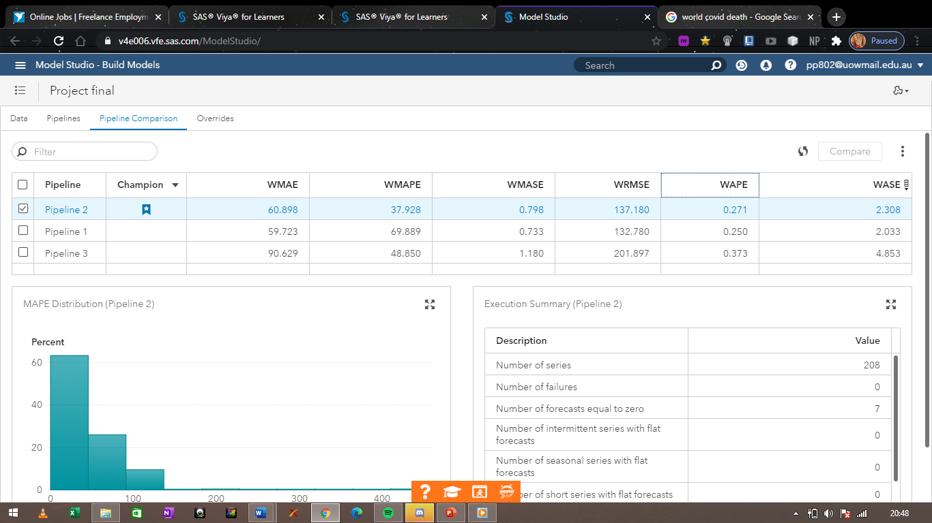

From the table above, it is evident that the Hierarchical model (pipeline 2) is the best model out of all three. It has the lowest weighted mean absolute percentage error and the weighted absolute percentage error, according to which the best model is selected.

## 3.5 Findings:

Lastly, the study emphasises on the forecasted results obtained from the best model. From figure 14, it is evident that the trend for number of deaths recorded per day worldwide will continue to be stagnant, though slowly decreasing. It is important to look at forecasted trends for each continent, which can be shown as follows:

### 3.5.1 Continent Wise Forecast

Hierarchical model is used to forecast values/trend for each continent, and the results are obtained below:

Africa:

Figure 16: Forecasted trend for Africa

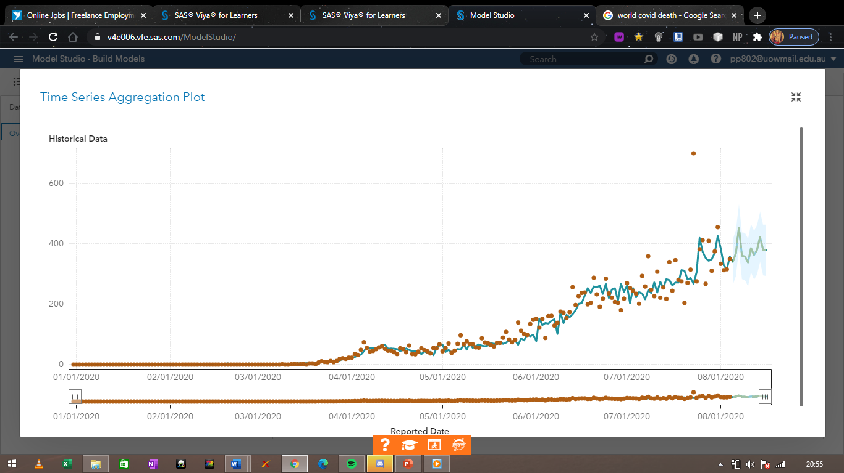

The forecasted trend is expected to stay on an upward trend for the forecasted future in Africa. The number of deaths recorded per day is expected to continue to rise further till it reaches its peak eventually.

Europe:

Figure 17: Forecasted trend for Europe

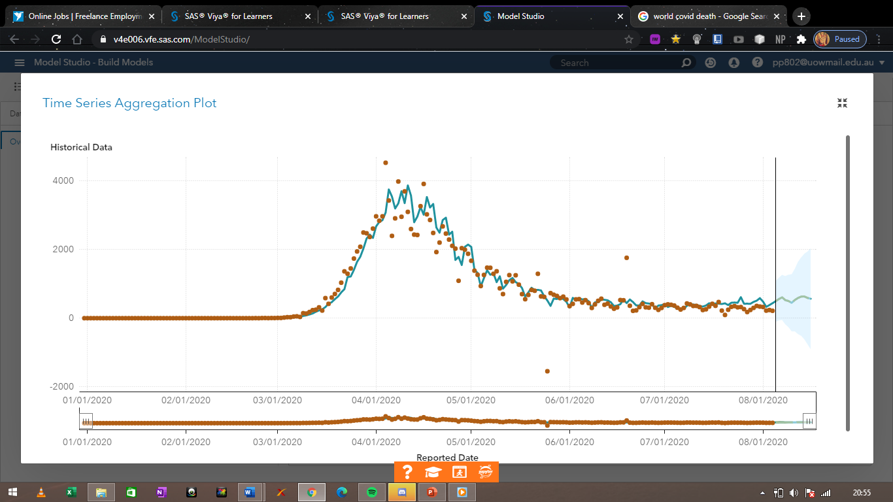

The forecasted trend for number of deaths recorded on a daily basis in Europe is expected to stagnate and flat line, and eventually fall.

America

Figure 18: Forecasted trend for North & South America

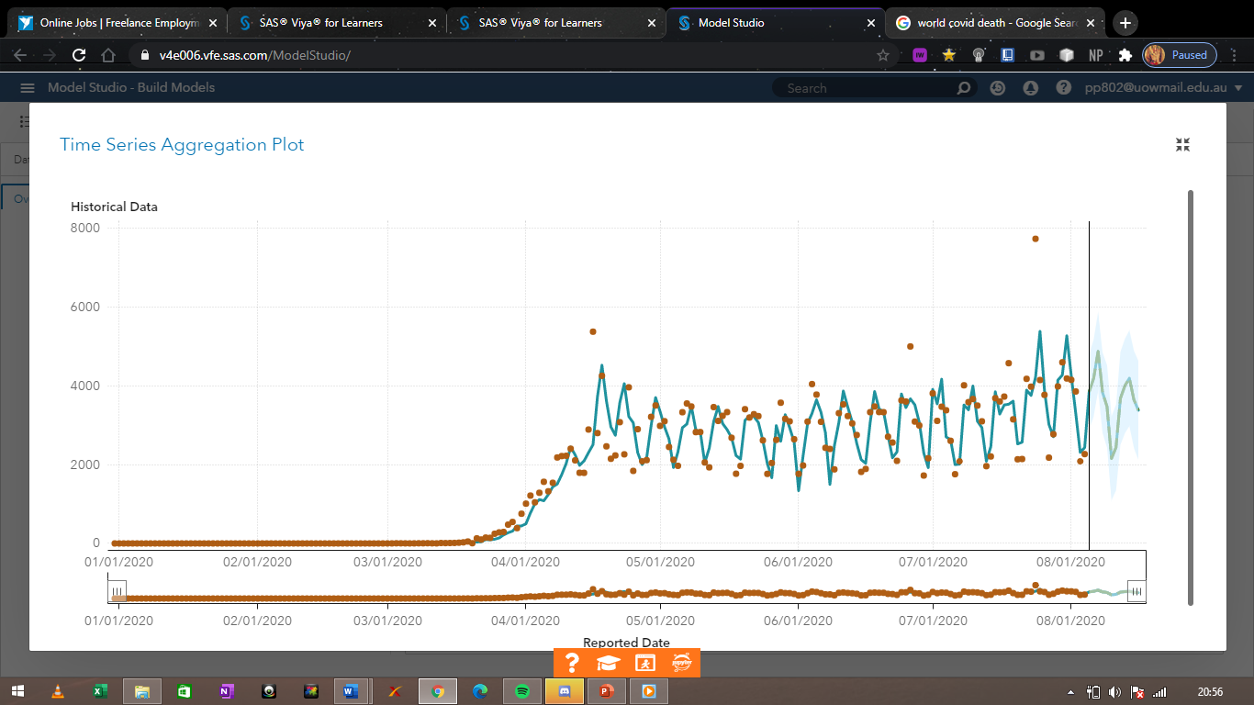

It is not possible to draw conclusive results from the trend observed by north and south America. Even though the number of deaths are extremely high, the trend includes a season element.

Asia

Figure 19: Forecasted trend for Asia

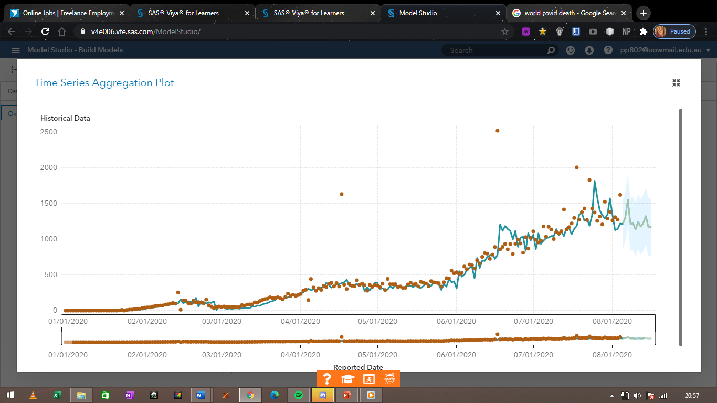

The trend forecasted for number of deaths recorded per day in Asia evidently shows a downward trend in the future.

Lastly, it is important to assess the effect of a 10% rise and fall in the predicted values on the forecasted trend. The following graph depicts the forecasted trend when the values are increased by 10%:

Figure : Effect of 10% increase in the forecasted values

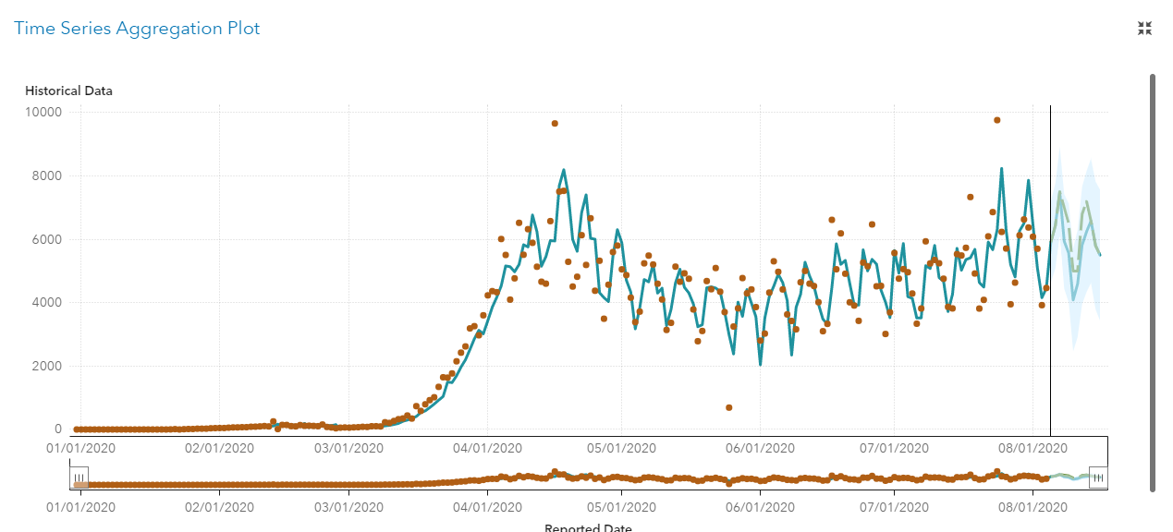

It is evident that the trend shifts drastically. While the forecasted value for august 6th is 5900, changing that value to 6500 shifts the graph upward significantly.

Figure : Effect of 10% decrease in the forecasted values

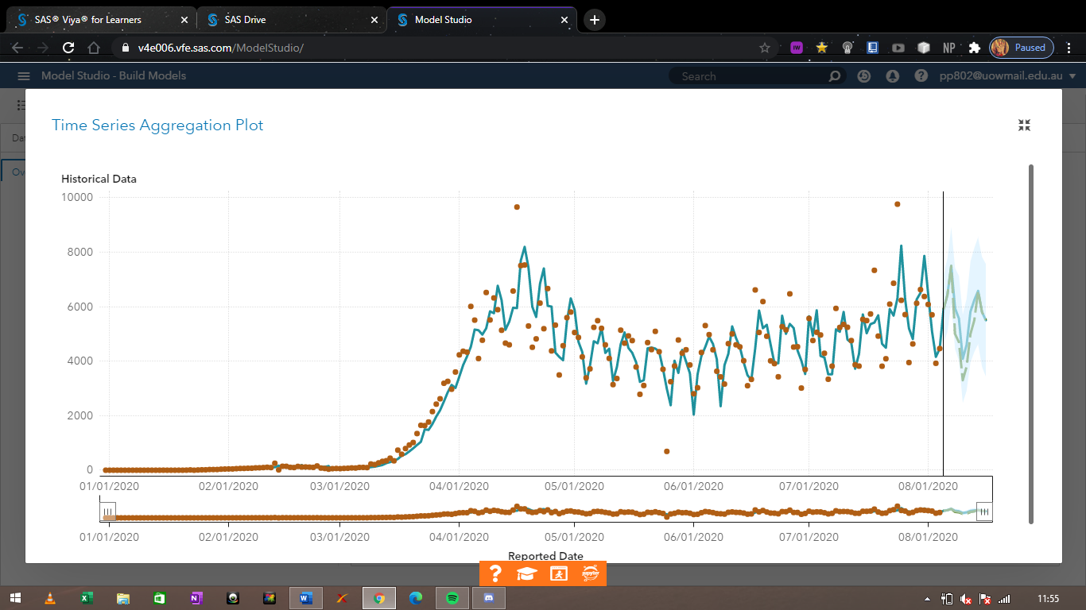

Similarly, a 10% decrease in the values significantly lowers the trend, and even puts it on a downward slope for the near future.

# 4. Discussion

The above study provides a detailed investigation into the future trends of Covid – 19, specifically number of deaths recorded per day. Confirmed cases are taken as independent variables and country as well as continents are taken as categorical variables. Exploratory analysis shows the condition of Covid – 19 worldwide and continent wise. It is evident that the number of deaths recorded per day are not expected to go down anytime soon, as some countries like India and Brazil have still not attained the peak level yet. Asia and Africa appear to have an upward trend when it comes to deaths recorded per day, while North & South America appear to possess a downward trend. Europe, attribution to quick action by the governments, has been on a downward trend for the past month. Africa has the least number of per day deaths whereas America has the highest.

Time series analysis is conducted using 3 different types of models, namely, Autoforecasting using ARIMA and ESM, Naïve model using 4 day moving average, and finally a Hierarchical model taking top down reconciliation as a method. Comparing the results of all three models proves that Hierarchical model appears to be the best and the most efficient, with the least amount of weighted mean absolute percentage error and mean absolute percentage error.

This model is then used to predict and forecast the trend of deaths per day for the foreseeable future. It is evident that Asia and Africa will continue to be on an upward trend till the continent achieve a peak level of deaths per day, while Europe’s trend is expected to stagnate.

# 5. Conclusion

The study provided useful insights and conclusive results into the situation of Covid 19 throughout the world, which can be used by policy makers and world leaders to make efficient and effective decisions. The most efficient model, Hierarchical model, predicted that most of the continents have still not attained the peak level of number of deaths recorded per day, and are still on an upward trend. Europe is the only continent, wherein governments showed quick response in dealing with the crisis. The continent achieved its peak level in May, and has since been on a downward trend.

Countries like India, Brazil, USA, Russia are still showing a rise in the number of deaths recorded per day, and are not expected to go down anytime soon. These countries need to make effective decisions in order to flat line the trend. While European countries like Italy, UK, etc appear to be on a downward trend.

# 6. Recommendations

Using the study, the author has the following recommendations for world leaders and policy makers:

* Countries which still appear to be on an upward trend when it comes to number of deaths recorded per day should be given more emphasis in this age of crisis.
* Reallocation of resources should be made from countries free from Covid 19 to countries still battling the same.
* Better staffing and more availability of ventilators, doctors, etc need to be conducted for countries like USA, India, Brazil.
* Lockdown needs to be imposed again in countries where the cases/deaths are rising again.